

Poll: Nearly half of Americans think the economy is doing well

BY BRETT SAMUELS / February 13, 2018, 7:37 AM

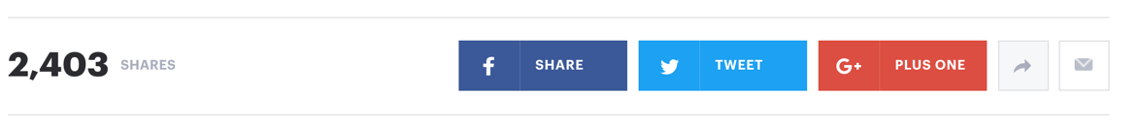

Just less than half of Americans believe the economy is doing well under President Trump, a new poll shows.

A CBS News Poll, released Sunday, found that 48 percent of Americans say the country is doing well economically, compared to 22 percent who say it’s doing poorly. Another 30 percent said it is neither doing well or poorly, according to the poll.

*Just under 50% of Americans believe the economy is doing well. Source: CBS News Poll, Feb. 10-12, 2018.*

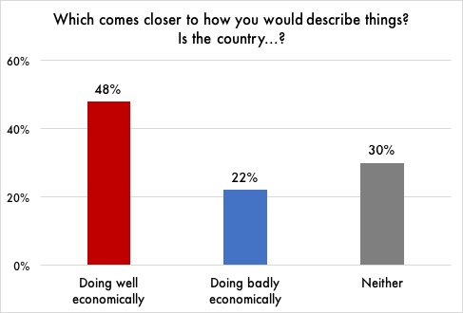

Another 49 percent of respondents indicated they believe the U.S. is run for the benefit of a few elites. By comparison, 28 percent said they believe the country is run for the benefit of the people, while 22 percent said neither, according to the poll, which was conducted Feb. 10-12. The poll had 2,164 respondents and has a margin of error of 2.6 percentage points.

President Trump has frequently touted the economy’s performance under his administration, often tweeting out reports of the stock market hitting new highs. The White House has also balked at suggestions that former President Obama is responsible for the current state of the economy.

A recent Quinnipiac poll showed 49 percent of respondents gave Obama credit for the current economy, compared to 40 percent who gave Trump credit.

Republicans have dramatically shifted their views of the US economy since the election 

The way Republicans view the economy has undergone a dramatic shift in the week since Donald Trump was elected president of the United States.

Gallup’s Economic Confidence Index, based on an average of how Americans view current economic conditions, registered a large shift among self-identified Republicans over a week time period following Election Day.

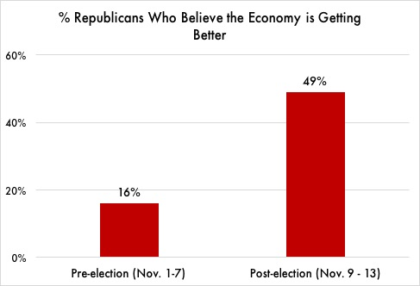“The increase in economic confidence mostly stems from Republicans’ more positive views after Republican Donald Trump won the election,” said the release from Gallup. “Republicans have had a dismal view of the economy — especially of its future direction — during Democratic President Barack Obama’s two terms.”

In fact, the proportion of Republicans saying the economy is getting better improved from 16% in the preelection period to 49% after Trump was elected.

*Republicans became more optimistic about the economy immediately following Trump’s election. Source: Gallup Polls, Nov. 1-13, 2017.*

It is important to note that despite the huge swing in Gallup’s polling, economic conditions – including rates of unemployment, inflation, and wage growth – have not changed over the past few weeks.

“Republicans are out of their minds if they think the economy is suddenly doing better because of Trump,” said Susan Thomas, a retired schoolteacher from Harrisburg, PA who voted for Hillary Clinton in 2016. “He’s just benefiting from the work Obama did. Anyone who can’t see that is delusional.”

President Trump has frequently touted the economy’s performance under his administration, often tweeting out reports of the stock market hitting new highs. The White House has also balked at suggestions that former President Obama is responsible for the current state of the economy.

Democrats have dramatically shifted their views of the US economy since the election 

The way Democrats view the economy has undergone a dramatic shift in the week since Donald Trump was elected president of the United States.

Gallup’s Economic Confidence Index, based on an average of how Americans view current economic conditions, registered a large shift among self-identified Democrats over a week time period following Election Day.

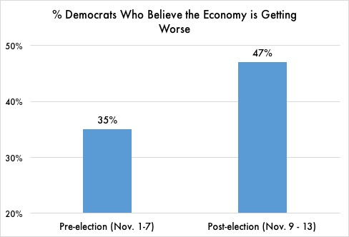

“Lagging economic confidence is mostly due to Democrats’ more negative evaluations after Donald Trump won the election,” said the release from CBS News. “Democrats had a more optimistic view of the economy — especially of its future direction — during President Barack Obama’s two terms.”

In fact, the proportion of Democrats saying the economy is getting worse increased from 35% in the preelection period to 47% after Trump was elected.

*Democrats became more pessimistic about the economy immediately following Trump’s election. Source: Gallup Polls, Nov. 1-13, 2017.*

It is important to note that despite the huge swing in Gallup’s polling, economic conditions – including rates of unemployment, inflation, and wage growth – have not changed over the past few weeks.

“Democrats are out of their minds if they think the economy is suddenly doing worse because of Trump,” said Susan Thomas, a retired schoolteacher from Harrisburg, PA who voted for the President in 2016. “He’s rescuing us from all the damage Obama did. Anyone who can’t see that is delusional.”

President Trump has frequently touted the economy’s performance under his administration, often tweeting out reports of the stock market hitting new highs. The White House has also balked at suggestions that former President Obama is responsible for the current state of the economy.

Republicans and Democrats have dramatically shifted their views of the US economy since the election 

The way Americans view the economy has undergone a dramatic shift in the week since Donald Trump was elected president of the United States.

Gallup’s Economic Confidence Index, based on an average of how Americans view current economic conditions, registered a large shift among both self-identified Democrats and Republicans over a week time period following Election Day.

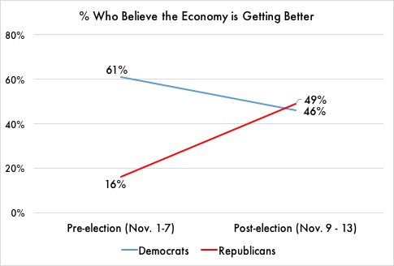 “Republicans have had a dismal view of the economy — especially of its future direction — during President Barack Obama’s two terms,” said the release from Gallup. “We now see Democrats becoming more pessimistic about the economy under a Republican president.”

In fact, the proportion of Republicans saying the economy is getting better improved from 16% in the preelection period to 49% after Trump was elected. For Democrats, it did the opposite, falling from 61% to 46%.

*Both Republicans and Democrats shifted their views immediately following Trump’s election. Source: Gallup Polls, Nov. 1-13, 2017.*

It is important to note that despite the huge swing in Gallup’s polling, economic conditions – including rates of unemployment, inflation, and wage growth – have not changed over the past few weeks.

Susan Thomas – a retired schoolteacher from Harrisburg, PA who voted for Donald Trump in 2016 —described Democrats’ views as “delusional.” “Can’t they see Trump is rescuing us from all the damage Obama did?” Her neighbor, Sandra Shelton, who voted for Hillary Clinton, had a very different view. “Trump is just benefitting from Obama’s economy,” she said. “Republicans are crazy if they don’t get that.”

President Trump has frequently touted the economy’s performance under his administration, often tweeting out reports of the stock market hitting new highs. The White House has also balked at suggestions that former President Obama is responsible for the current state of the economy.